Fix bugs :

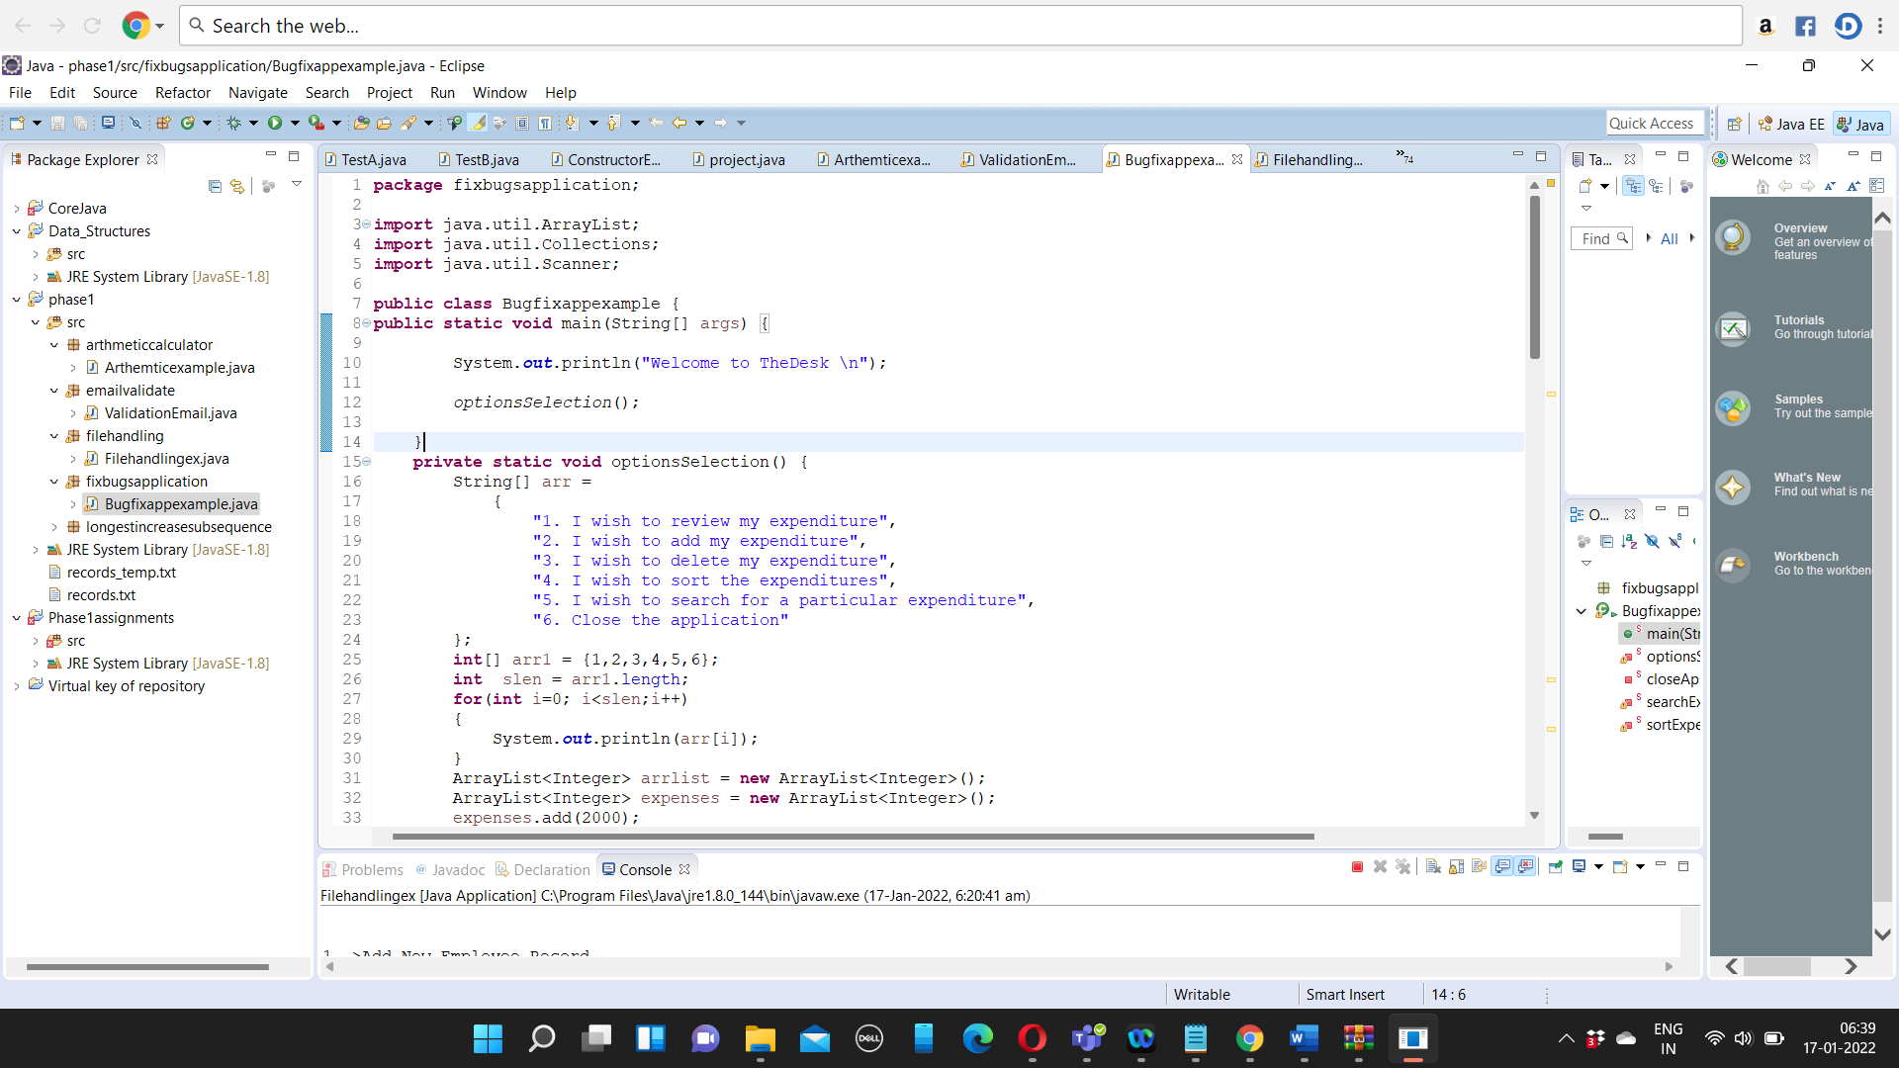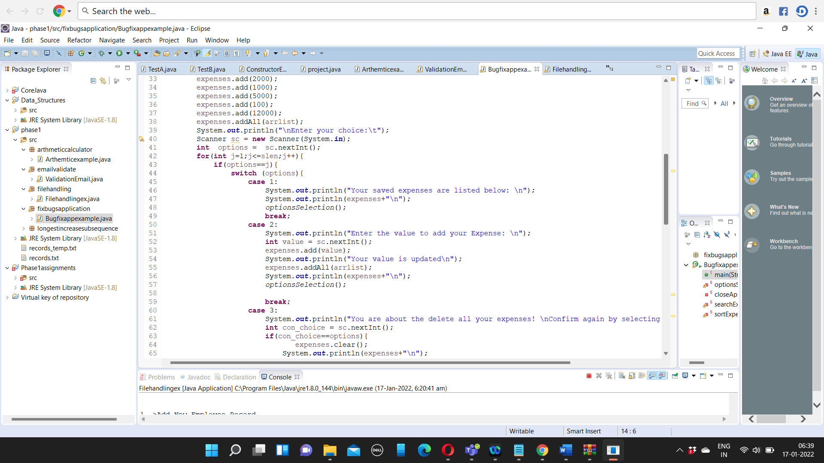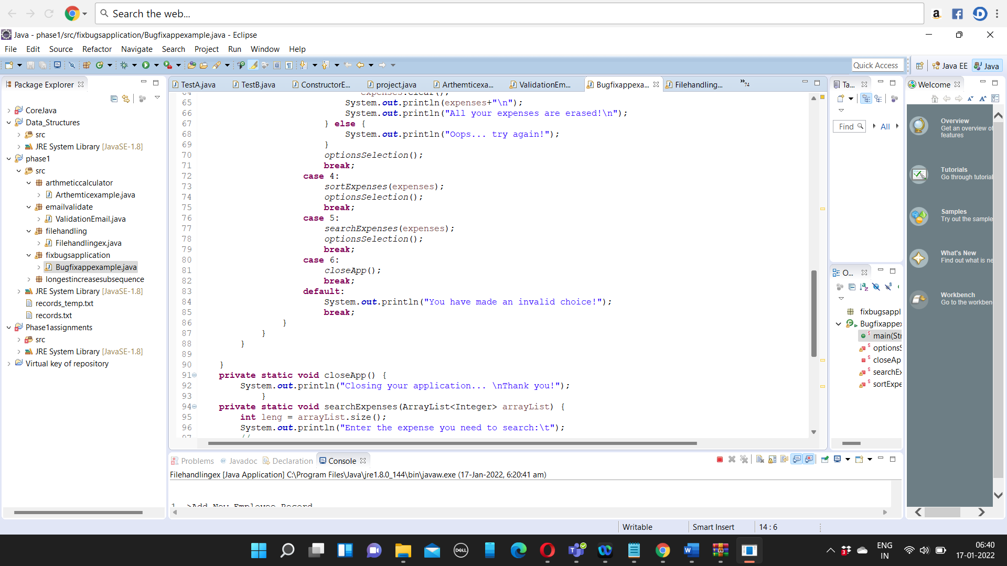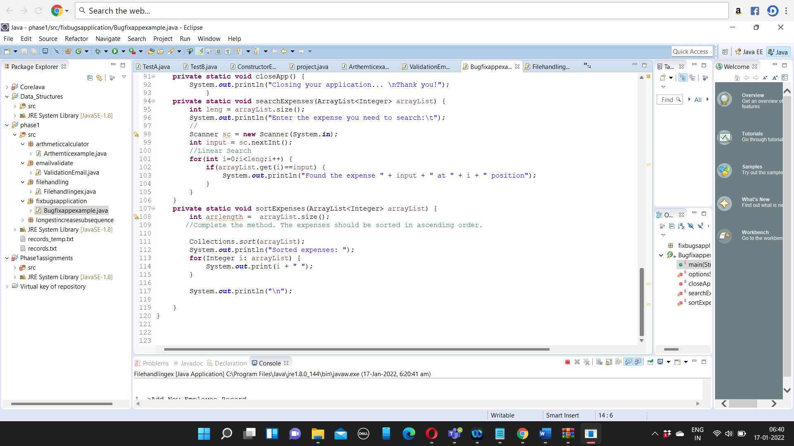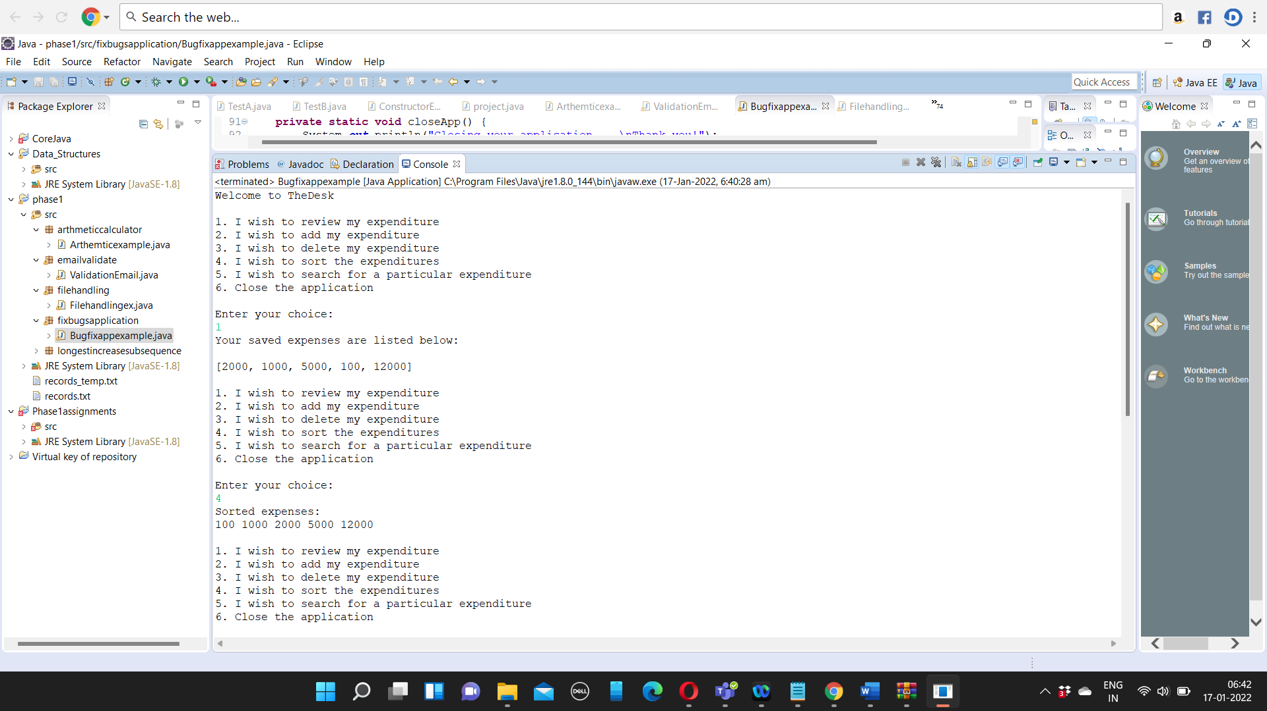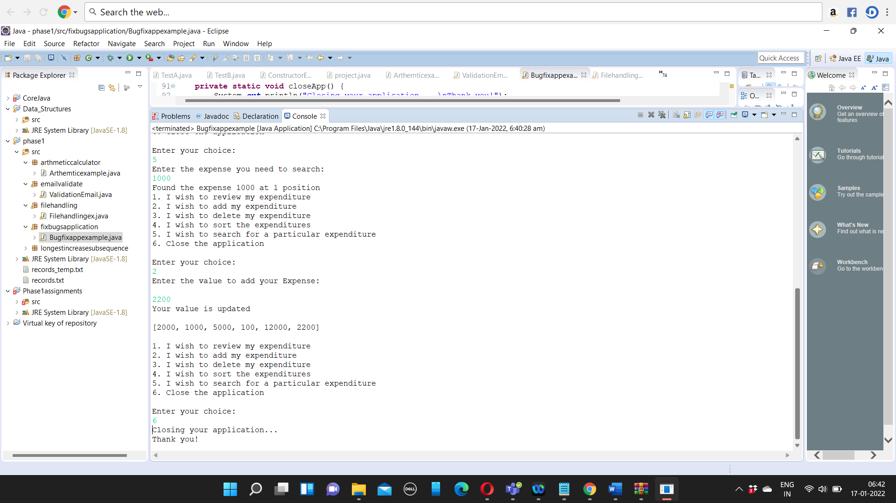

Program :

**package** fixbugsapplication;

**import** java.util.ArrayList;

**import** java.util.Collections;

**import** java.util.Scanner;

**public** **class** Bugfixappexample {

**public** **static** **void** main(String[] args) {

System.***out***.println("Welcome to TheDesk \n");

*optionsSelection*();

}

**private** **static** **void** optionsSelection() {

String[] arr =

{

"1. I wish to review my expenditure",

"2. I wish to add my expenditure",

"3. I wish to delete my expenditure",

"4. I wish to sort the expenditures",

"5. I wish to search for a particular expenditure",

"6. Close the application"

};

**int**[] arr1 = {1,2,3,4,5,6};

**int** slen = arr1.length;

**for**(**int** i=0; i<slen;i++)

{

System.***out***.println(arr[i]);

}

ArrayList<Integer> arrlist = **new** ArrayList<Integer>();

ArrayList<Integer> expenses = **new** ArrayList<Integer>();

expenses.add(2000);

expenses.add(1000);

expenses.add(5000);

expenses.add(100);

expenses.add(12000);

expenses.addAll(arrlist);

System.***out***.println("\nEnter your choice:\t");

Scanner sc = **new** Scanner(System.***in***);

**int** options = sc.nextInt();

**for**(**int** j=1;j<=slen;j++){

**if**(options==j){

**switch** (options){

**case** 1:

System.***out***.println("Your saved expenses are listed below: \n");

System.***out***.println(expenses+"\n");

*optionsSelection*();

**break**;

**case** 2:

System.***out***.println("Enter the value to add your Expense: \n");

**int** value = sc.nextInt();

expenses.add(value);

System.***out***.println("Your value is updated\n");

expenses.addAll(arrlist);

System.***out***.println(expenses+"\n");

*optionsSelection*();

**break**;

**case** 3:

System.***out***.println("You are about the delete all your expenses! \nConfirm again by selecting the same option...\n");

**int** con_choice = sc.nextInt();

**if**(con_choice==options){

expenses.clear();

System.***out***.println(expenses+"\n");

System.***out***.println("All your expenses are erased!\n");

} **else** {

System.***out***.println("Oops... try again!");

}

*optionsSelection*();

**break**;

**case** 4:

*sortExpenses*(expenses);

*optionsSelection*();

**break**;

**case** 5:

*searchExpenses*(expenses);

*optionsSelection*();

**break**;

**case** 6:

*closeApp*();

**break**;

**default**:

System.***out***.println("You have made an invalid choice!");

**break**;

}

}

}

}

**private** **static** **void** closeApp() {

System.***out***.println("Closing your application... \nThank you!");

}

**private** **static** **void** searchExpenses(ArrayList<Integer> arrayList) {

**int** leng = arrayList.size();

System.***out***.println("Enter the expense you need to search:\t");

//

Scanner sc = **new** Scanner(System.***in***);

**int** input = sc.nextInt();

//Linear Search

**for**(**int** i=0;i<leng;i++) {

**if**(arrayList.get(i)==input) {

System.***out***.println("Found the expense " + input + " at " + i + " position");

}

}

}

**private** **static** **void** sortExpenses(ArrayList<Integer> arrayList) {

**int** arrlength = arrayList.size();

//Complete the method. The expenses should be sorted in ascending order.

Collections.*sort*(arrayList);

System.***out***.println("Sorted expenses: ");

**for**(Integer i: arrayList) {

System.***out***.print(i + " ");

}

System.***out***.println("\n");

}

}